Quality Assured (QA) Sod Program: provides documented proof of conformance to Minnesota Department of Transportation (MnDOT) specifications for specified sod types.

Look for this gold label!

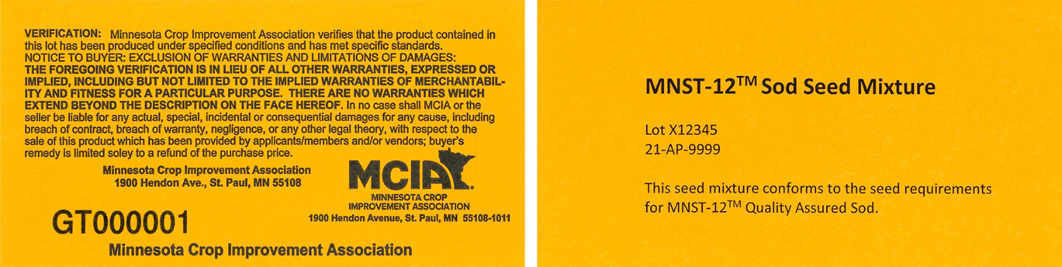

- Seed must be obtained from an approved QA Sod Seed Vendor (for a current list go to www.mncia.org or contact the MCIA office).
- QA Sod Seed Vendors warrant that seed mixes with QA Sod Seed Mixture labels meet current requirements of the QA Sod Program and MnDOT specifications for salt tolerant sod.
Company Name and Address | Contact Name and Information
Agassiz Seed & Supply Inc.  445 7th St. NW  West Fargo ND 58078 | Al Holleman  PH: 701-282-8118  FAX: 701-282-9119  al@agassizseed.com
Ramy Turf Products  1329 N Riverfront  Mankato MN 56001 | Mike Ramy Jr.  PH: 507-387-4091  FAX: 507-387-7033  mikejr@ramycompanies.com
Rivard's Turf & Forage Inc  3150 27th Ave N  Grand Forks ND 58203 | Larry Rivard  PH: 701-330-3699  FAX: 866-484-6150  sales@rivards.com
Twin City Seed Company  7265 Washington Ave S  Edina MN 55439 | Paul Kubista or Andy Keating  PH: 952-944-7105  FAX: 952-944-7239  PKubista@twincityseed.com
- Minnesota Crop Improvement Association (MCIA) inspects these vendors annually to verify seed handling and labeling procedures comply with MnDOT and seed law requirements. MCIA is the official seed certification agency in Minnesota.

